Task 2 - Which British celebrity can you see in the caricatures? Name the person or the character.
Team number:
Task 2.
Score: ____ out of 8

-  He is the star of an American series.

- 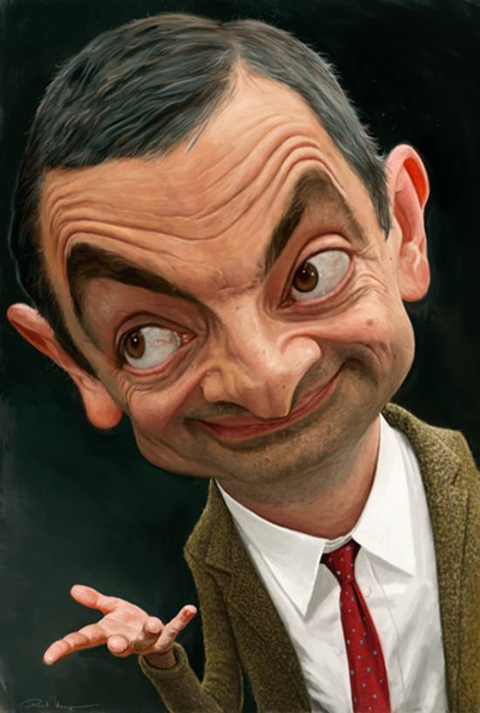 He appeared in films, cartoons, and on TV.

- He starred in many romantic comedies.

- 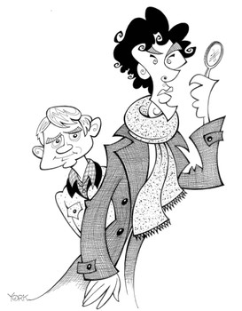They solve crimes: a famous detective and his doctor friend.

- 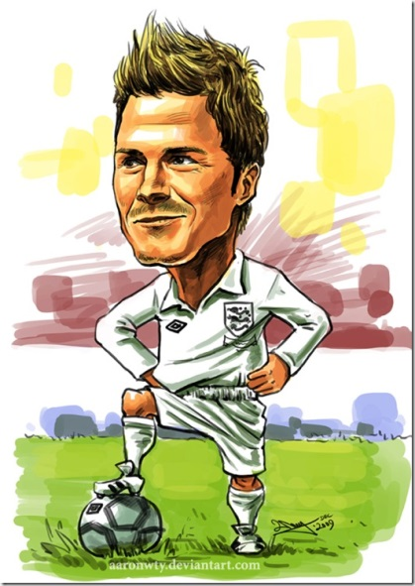 A world famous footballer, his wife is an ex spice Girl.

- 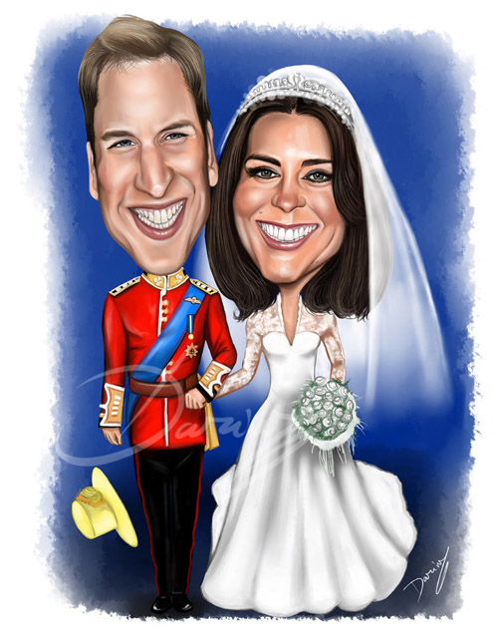A famous couple who are expecting their second child any minute.

- 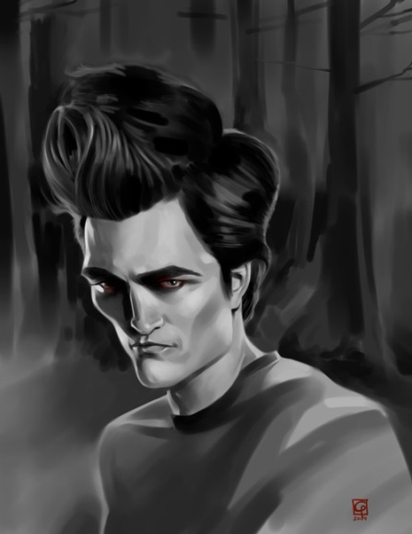 In his most famous film he was a vampire who fell in love with a flesh and blood girl

- 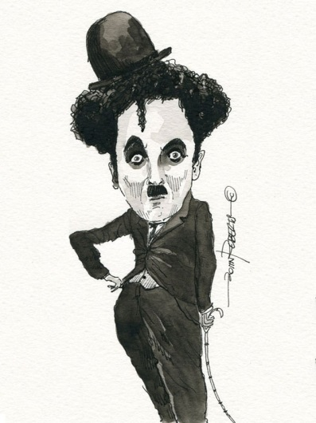World famous British comedian who started as a silent movie star.

